**Hospital Management System**

**Database**

**Introduction**-

The project Hospital Management system includes registration of patients, storing their details into the system, and also computerized billing in the pharmacy, and labs. The software has the facility to give a unique id for every patient and stores the details of every patient and the staff automatically. It includes a search facility to know the current status of each room. Users can search the availability of a doctor and the details of a patient using the id. The Hospital Management System can be entered using a username and password. It is accessible either by an administrator or receptionist. Only they can add data into the database. The data can be retrieved easily. The interface is very user-friendly. The data are well protected for personal use and make the data processing very fast. Hospital Management System is powerful, flexible, and easy to use and is designed and developed to deliver real conceivable benefits to hospitals. Hospital Management System is designed for multispeciality hospitals, to cover a wide range of hospital administration and management processes. It is an integrated end-to-end Hospital Management System that provides relevant information across the hospital to support effective decision-making for patient care, hospital administration, and critical financial accounting, in a seamless flow. Hospital Management System is a software product suite designed to improve the quality and management of hospital management in the areas of clinical process analysis and activity-based costing. Hospital Management System enables you to develop your organization and improve its effectiveness and quality of work. Managing the key processes efficiently is critical to the success of the hospital helps you manage your processes.

Hospital Management System is a system enabling hospitals to manage information and data related to all aspects of healthcare – processes, providers, patients, and more, which in turn ensures that processes are completed swiftly and effectively. When one thinks of the various aspects and departments of a hospital, it becomes apparent that an HMS is critical. The hospital database management system was introduced in 1960, and has greatly evolved since then – with the ability to integrate with the existing facilities, technologies, software, and systems of a hospital. Today, patients can begin the process of healthcare in the palm of their hand – the mobile devices and apps – make this possible. This process then moves to the healthcare providers and hospitals

Sakshi Yagnik

**Database Design-**

Tables: 1.Doctor

2.Patient

3.Lab_d

4.inpatient

**Creating Tables-**

Doctor:

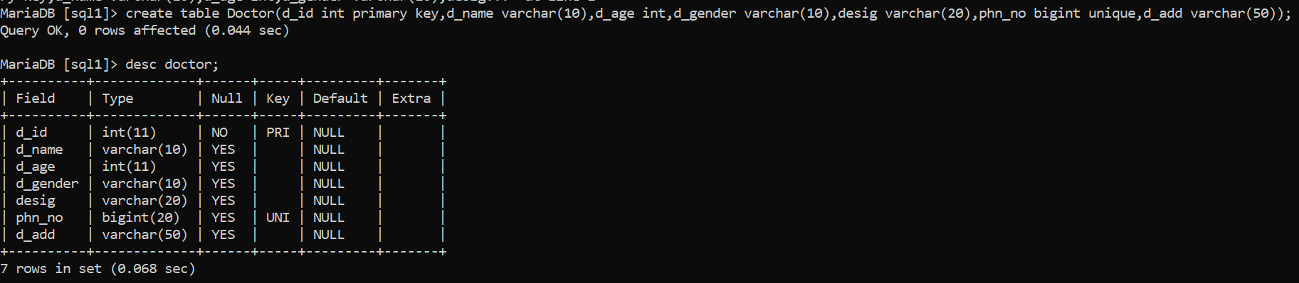

Patient:

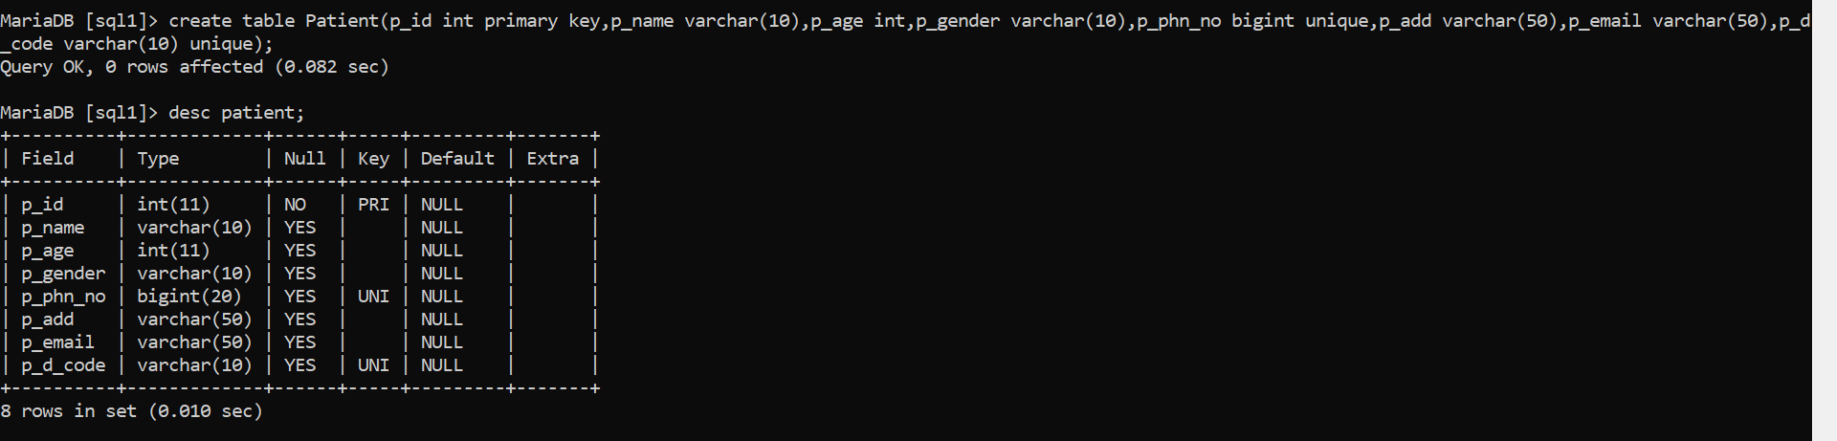

Lab_d:

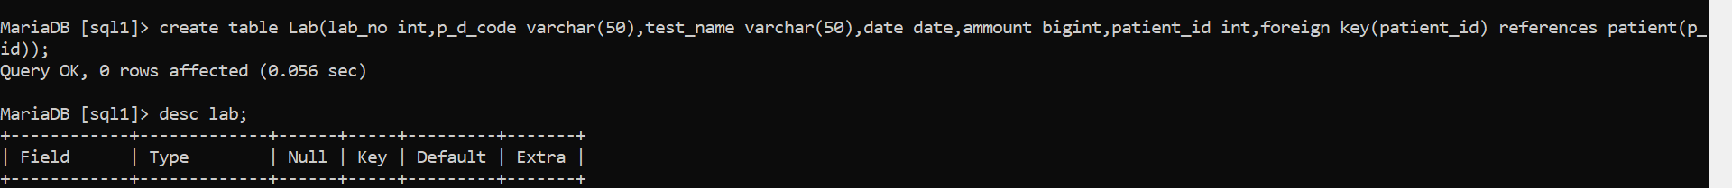

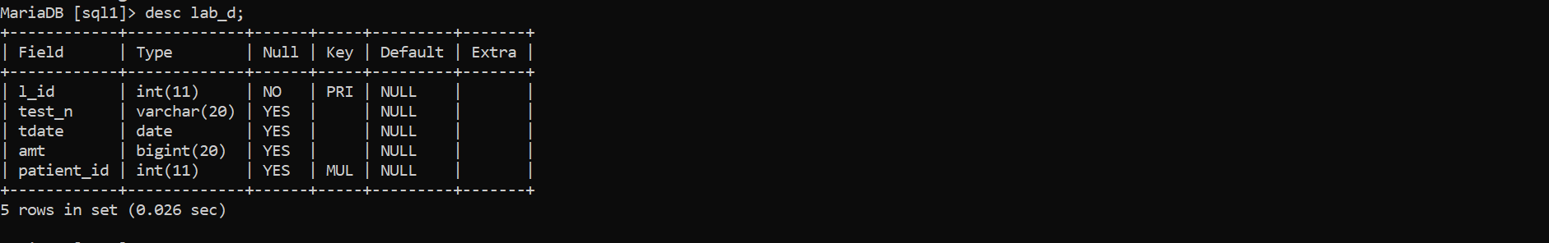

Inpatient:

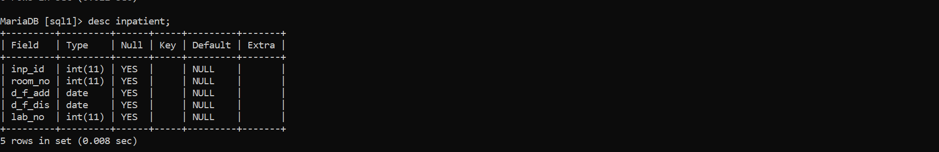

Tables in Database:

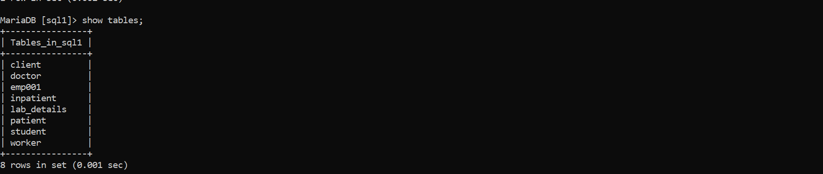

**Data Definition Language (DDL)**-

1.create:



2. Alter: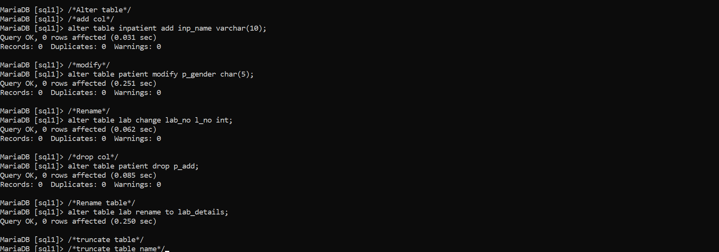

Primary And foreign Key:

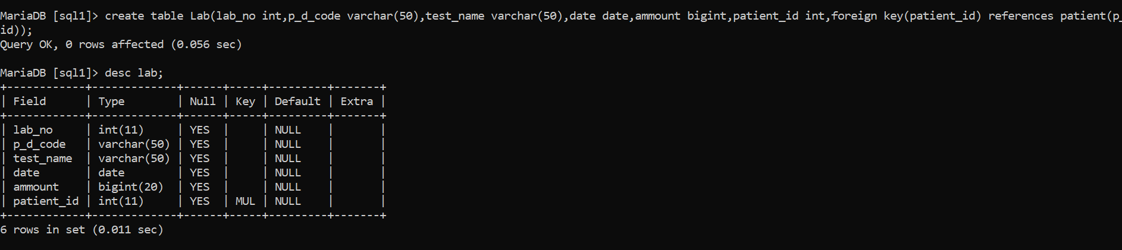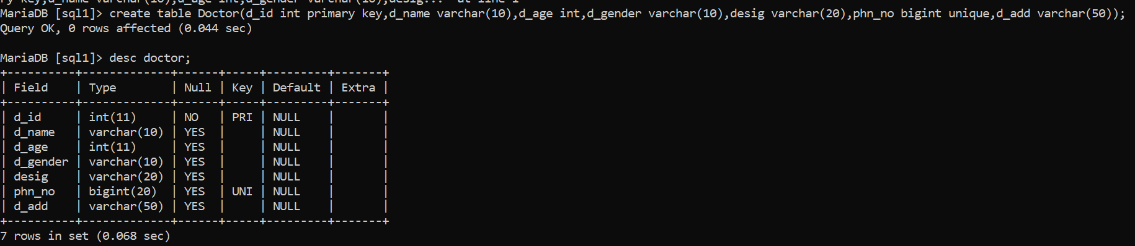

**Data Manipulation language(DML)-**

1.Insert:

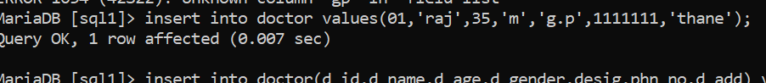

2.Update:

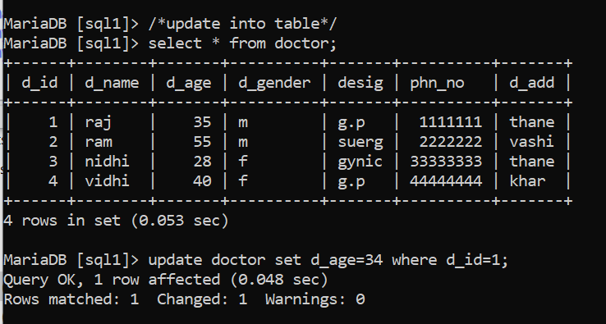

3.Delete:

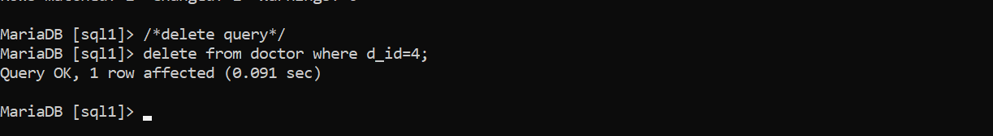

**Data Query language(DQL) -**

1.select query:

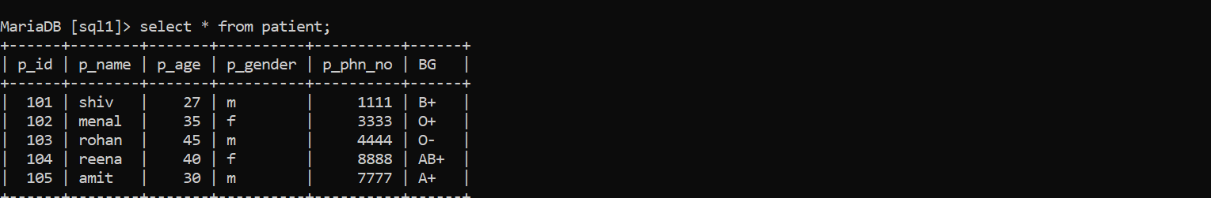

Where clause:

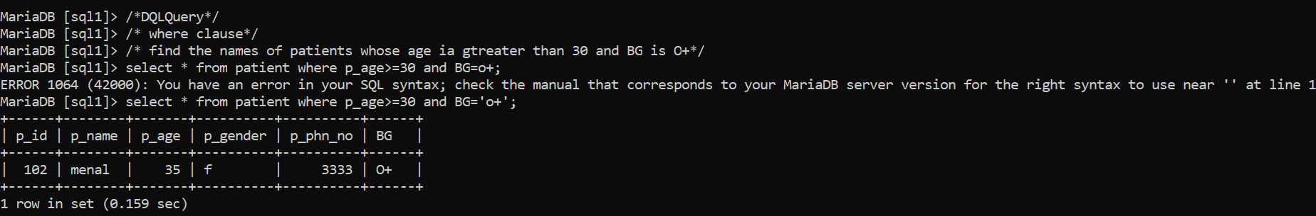

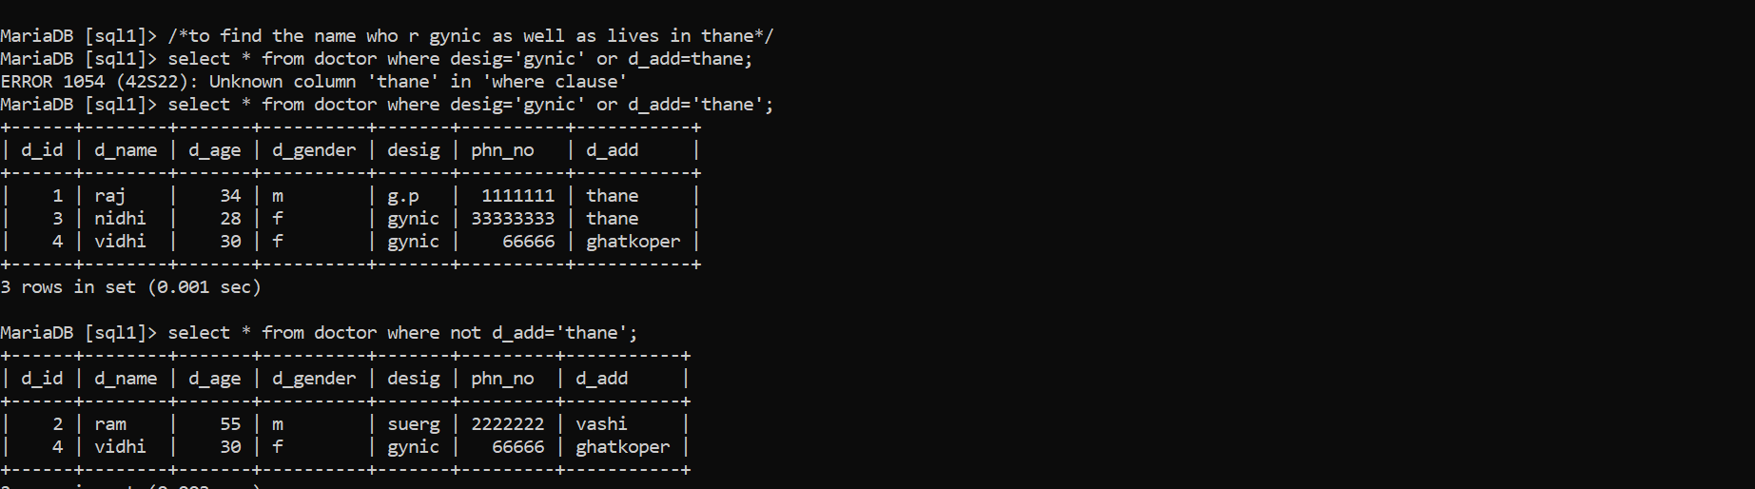

Like operator:

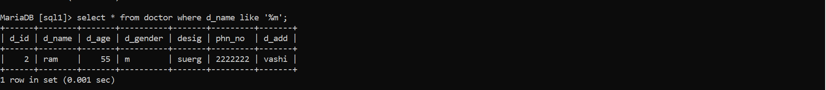

Order by clause:

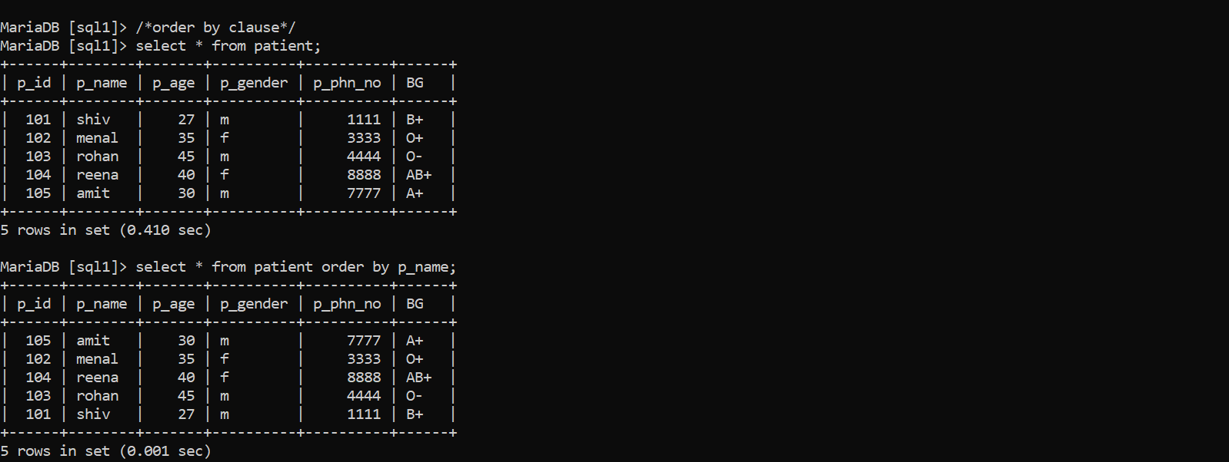

Group by and Having clause:

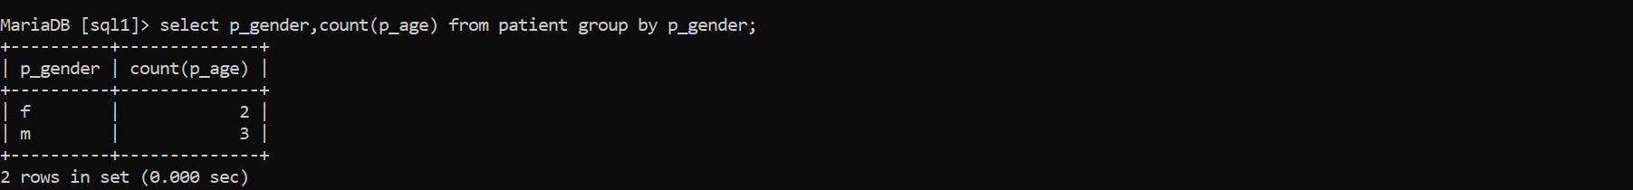

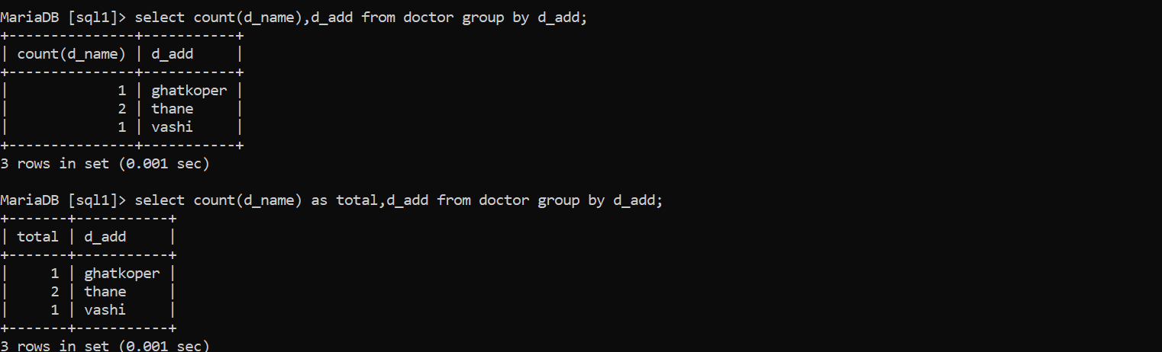

**In-Built Function:**

String, Date And Aggregate Function:

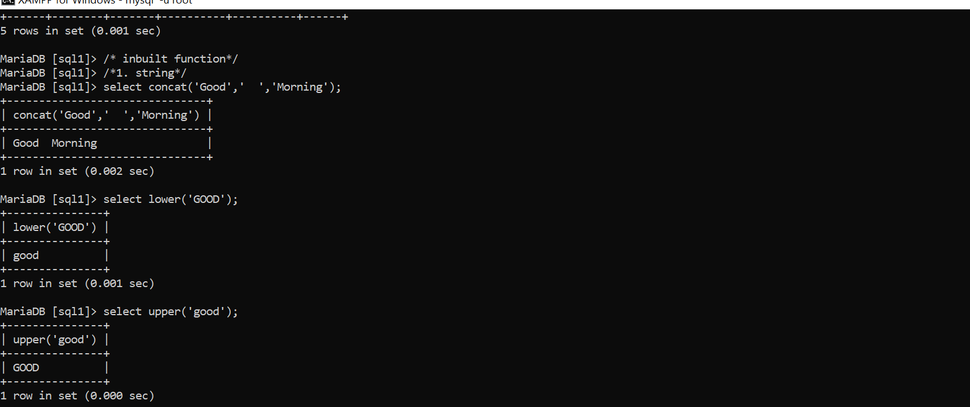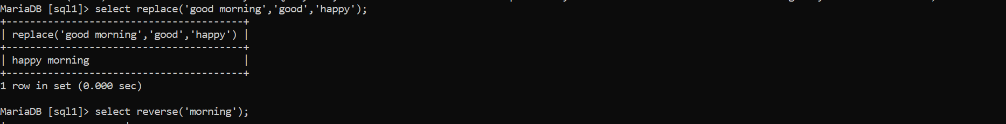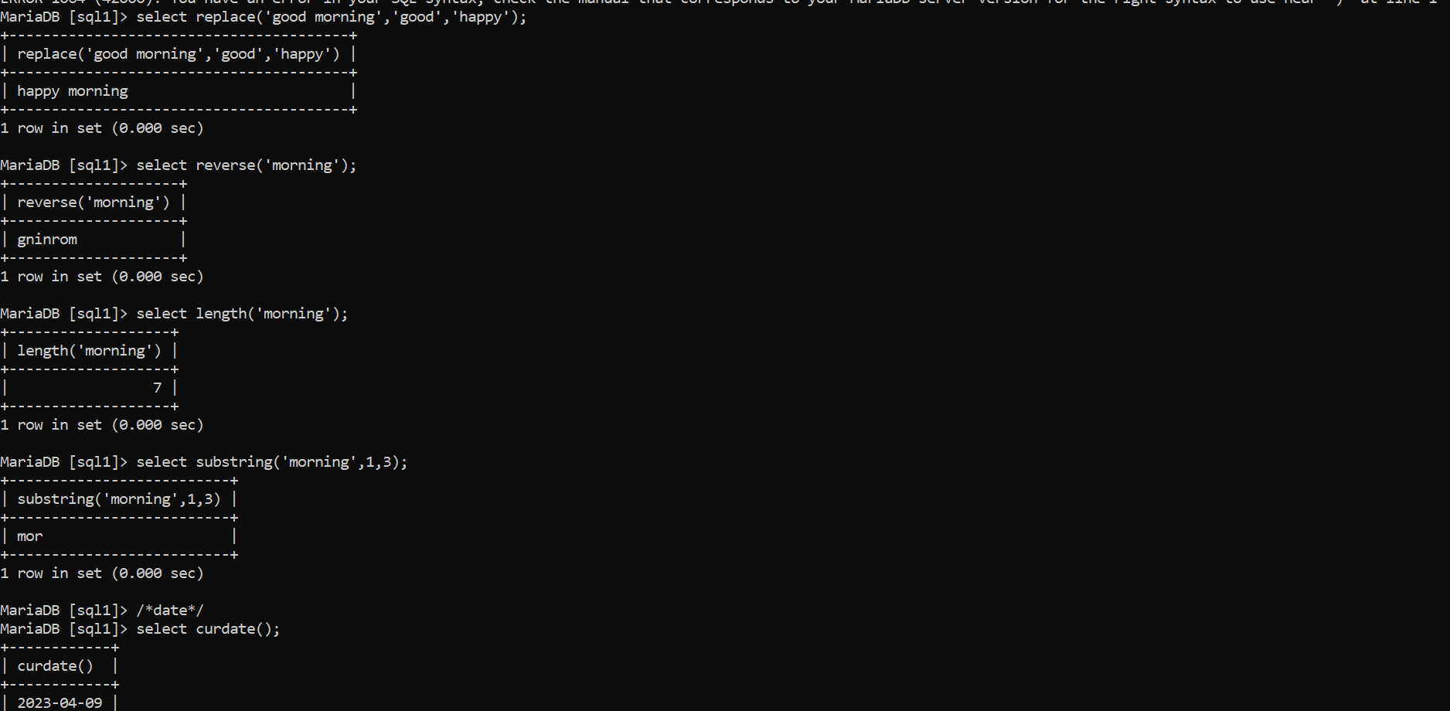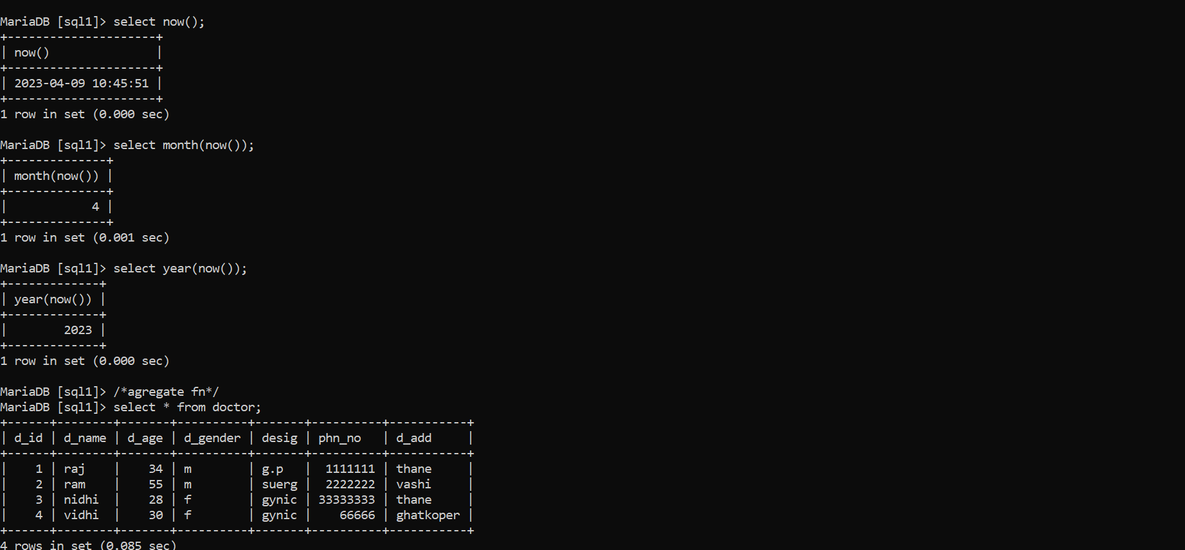

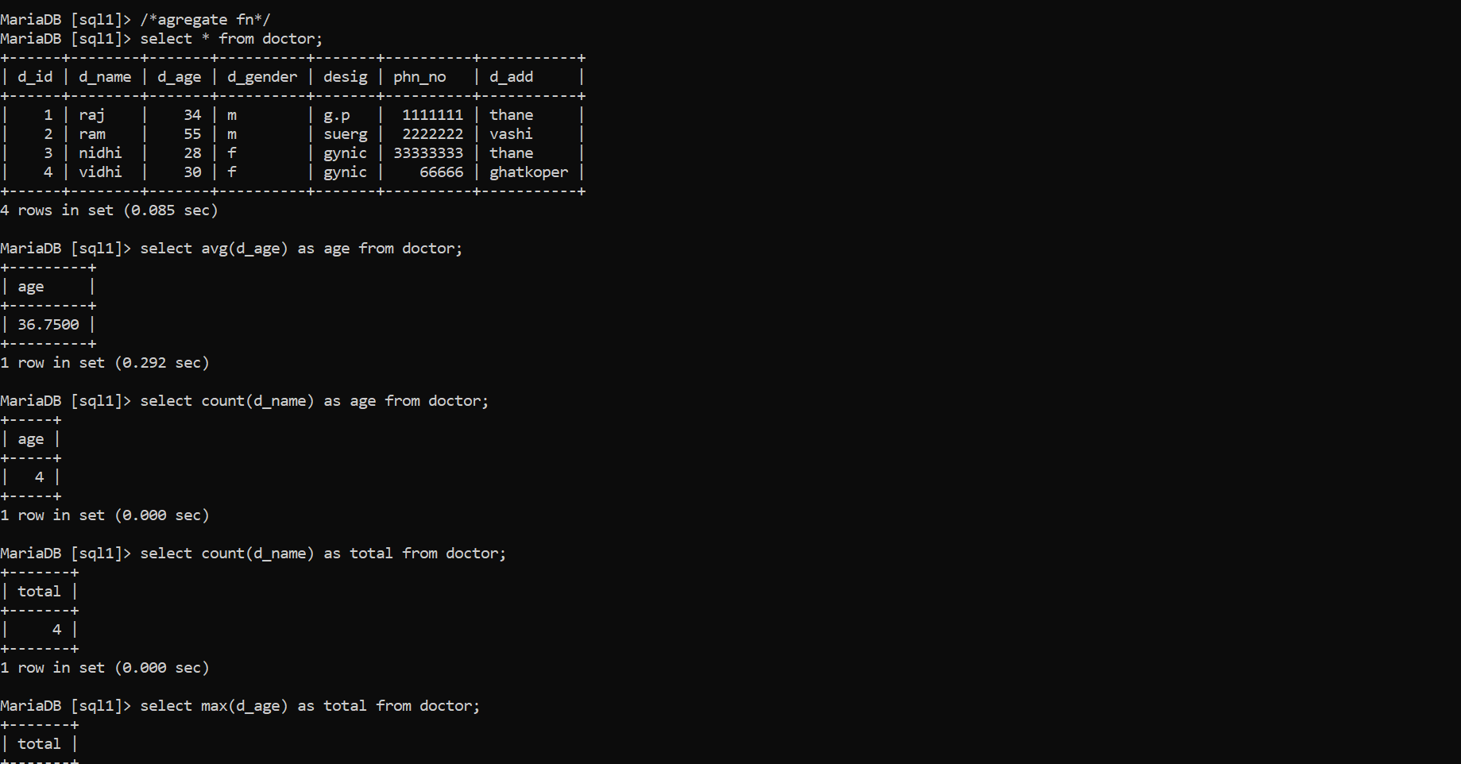

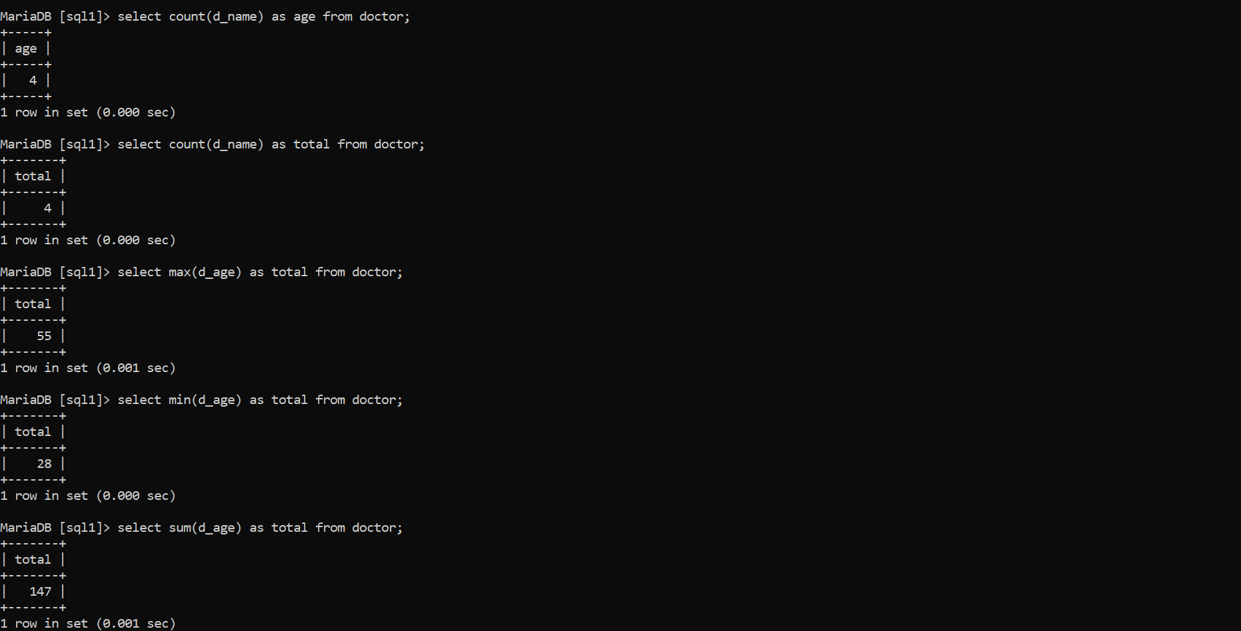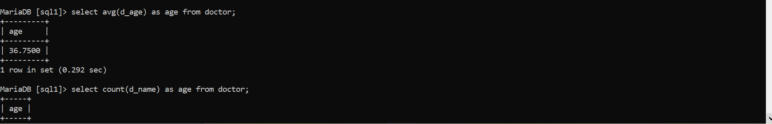

**Subquery-**



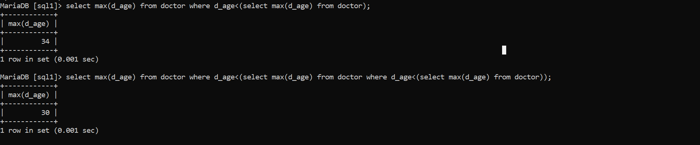

**Joins-**

Inner join, Left Outer join And Right Outer Join:

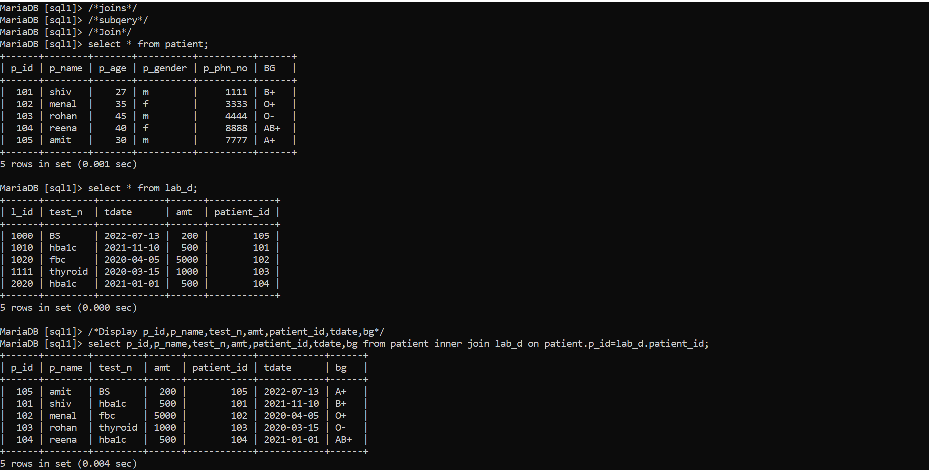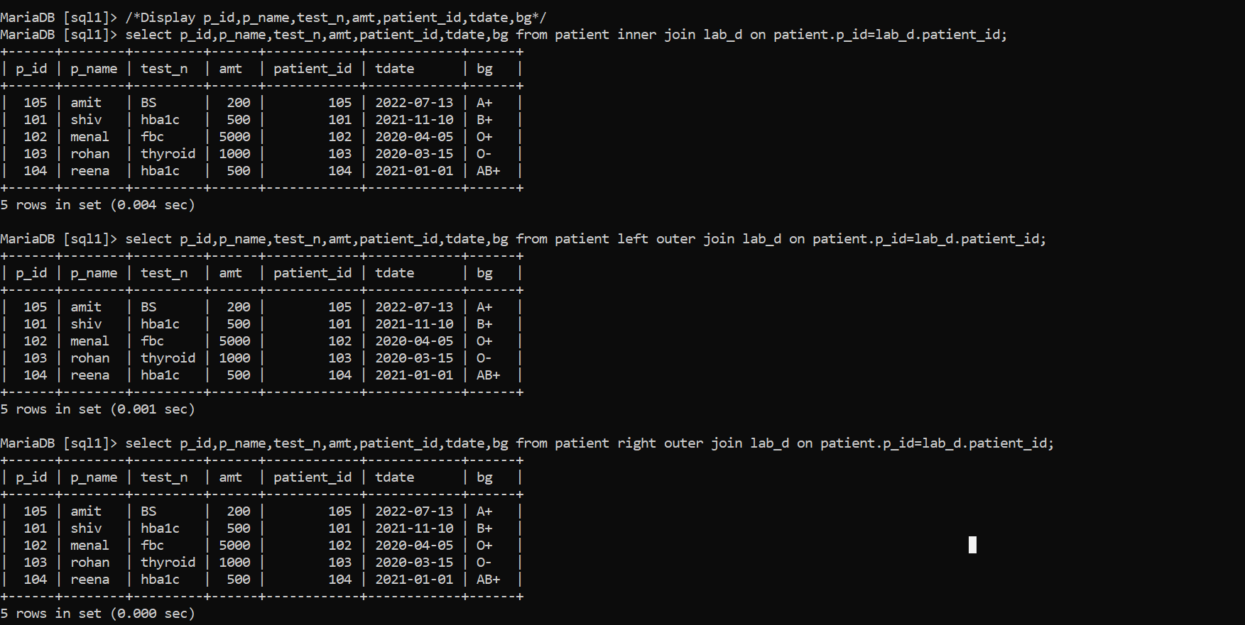

Views:

